Correspondence address:

Peter and Pauline Wood
46 Ballatessan Meadow, Peel, Isle of Man
castleviewapartment1@gmail.com

Tel: 07624 420712
​
Isle of Man

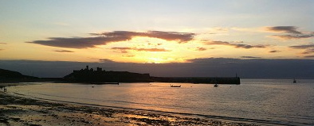

Castleviewpeel Self Catering Booking Form

Please read the Booking Conditions before completing and returning this Form.

Name: | Address:
Telephone (daytime): | Email:
Telephone (evening): | Arrival date: | Departure date:
Number in party: | Total Rental Cost: | Deposit now due:

Any special requirements/notes?

Please choose tick appropriately:

I enclose Cheque/payable to J P & P A WOOD

I am paying by direct bank transfer

I/We have read the terms and conditions

You may send my receipt Please send my receipt

by email: by post:

I have read, and I accept the Booking Conditions which accompany
this Booking Form

Please sign here: or if typing place x in box:

Date:

